CHANGE OF ADDRESS

If you have moved house recently, or are about to move, please fill in the address slip below and either hand it to your elder, or post it to Sheila Bertram, 42 Pentland View, Edinburgh EH10 6PS.

Thank you.

Name(s): ……………………………………………………………………………………

OLD address: ……………………………………………………………………………..
………………………………………………………………………..............................

NEW address: ……………………………………………………………………………
................……………………………………………………………………………………

NEW Phone Number: ……………………………………………………………….

Moving date: …………………………………………………………………………….

Tron Kirk Gilmerton and Moredun
Church of Scotland Edinburgh, Registered Charity SC009274
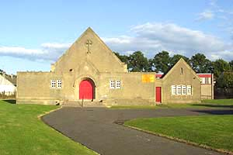 | 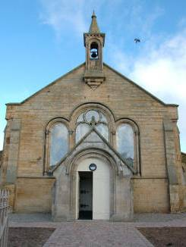

THE CHRONICLE
JULY 2019

SUNDAY SERVICES

TRON KIRK 10.30am

GILMERTON CHURCH “THE HUB” 5.00pm

MINISTER - REV CAMMY MACKENZIE

Magazine of the Tron Kirk Gilmerton and Moredun
LETTER FROM OUR MINISTER

It has been a very interesting few days indeed for me as I have gone about my week. I am sure that many of you too have had a few interesting moments. I had the pleasure of attending Ron Maxton’s funeral in Dunipace last Wednesday with some of the ladies from Tron Kirk. He was minister at Tron from 1967 to 1988 and it was wonderful to hear so many stories of his life and work from the minister who led the service and two others who also spoke about Ron’s life. He was a man I only met once when he came along to Tron’s 60th anniversary and we had a common connection in Garvald where he had lived as a boy and I had been minister for 13 years. I will tell you the truth that it was a slightly edgy experience for me to hear of Ron’s death because it brought it home the fact that there will come a Sunday or other day of the week when it is announced that Cammy has died and that Cammy’s service will be held in such and such a place. I have never been accused of being morbid and I do not accept that my feelings over Ron’s death are morbid either because essentially at his service as at mine there is going to be a great sense of GOING HOME rather than leaving home! I do hope we manage to get the Eulogy his Minister gave as it was fantastic but I want to include one section of it for you here in my part of our newsletter.

There was a photo of Ron as a little boy around 3-4 with a pageboy haircut and a White frilly shirt on. His mum and dad were on either side of him as the 3 of them looked at the camera. He was an only child and I am sure he was much loved. His minister said of the photo "You look just like a future moderator”, to which Ron replied, "NO I have never been ambitious”! His minister then spoke words to Ron which I loved….."Not ambitious Ron but most conscientious indeed”. I have never been ambitious either and perhaps that is why I appreciated her words so much. I have only ever since I became a minister wanted to serve God and the local church and community. I have tried to do my part on Presbytery both in East Lothian and here in Edinburgh but never to the loss of what I feel most called to do which is serve my King in the locus to which I am called to Minister in His name. Now that does not mean that I am suspicious in any of those who do serve in the higher courts of the Church but that must be their calling and not mine.

I took part in another service of worship this past weekend which was this

time a wedding and not a funeral. It was of a friend of mine from my way and disband past in the late 60s and early 70s. My friend Ran or Robert as
his wife and mother call him left Ferguslie Park behind when we were about 12 or so. I never really saw him much more than two or three times until long after I moved to Haddington with Dilma in 97. He got in touch with me as a mutual friend told him I had become a minister and was serving in West Church Morham and Garvald. He had many years prior moved to Dunbar and it was great to re-connect with him after such a long period of time. It was a beautiful wedding at the Dunbar Golf club and we had a wonderful time and through Robert I had the pleasure of re-uniting with another old pal who went to live in Blackpool 36 years ago. Pete and I had a great time both at the wedding practice and at the wedding chatting about the old days when all 3 of us could only be best describe as "wild boys"…..As the wedding guests began to arrive a young man arrived carrying his little girl in his arms and he and I got chatting for a few minutes and it turned out he was the partner of my Friend Rab’s grand daughter and he knew me instantly for I had been the minister through most of his growing up at Haddington Infant, Kingsmeadow Primary and Knox Academy! He flattered me by saying wait till I tell the guys that I met Mr Cammy because that is what they all called me from Nursery to S6 believe it or not and I thought to myself well what do you know something WAS sinking in all those years gone by and still most likely is today.

Dear friends we live our lives every day hour by hour minute by minute. Let us be like Ron Maxton (whether we are ambitious or not) and let us be conscientious in serving the Lord, Our Lord Jesus so that like Ron we might hear His words one day saying to us….Well done my good and faithful servant”.

God bless you all over the summer weeks.
May you and all of us experience a new blessing in God’s love and may we be refreshed greatly by His wonderful Holy Spirit.

Cammy

T A G

This group meets on a Thursday Afternoon from the beginning of September until June. We meet every second Thursday from 2.00pm until approximately 3.30pm. If you are free and are looking for something to do on a Thursday afternoon please come along and join us. It is mostly a fun afternoon and sometimes we do have a speaker. The cost is £1.00 and tea and biscuits are supplied.

If you would like any further information please speak to Alice Laing, Sheena Anderson or Pat Wilson.

******************************

HOME COMMUNION

You may be one of our more elderly on infirm members who are not now able to attend church and also miss out on Communion Sundays. If you would like to receive Communion in your own home please contact the minister Cammy Mackenzie on 664 7538 or our Session Clerk Sheila Bertram on 445 2129, who will be able to arrange this for you.

******************************

LIFE and WORK MAGAZINE

If you would like to receive a copy of the Church of Scotland Life and Work Magazine please speak to Sheena Anderson.

 |  | FLOWER LIST
JULY |  |  | SEPTEMBER
07 | Anna & Bill Cormack |  | 01 | Margaret Ballantyne
14 | May Neil |  | 08 | Betty Hastings
21 | Alice & Sheila Bertram |  | 15 | Muriel Galbraith
28 | Janice Gordon |  | 22 | Moira Morris
 |  |  | 29 | Moira Rendall
AUGUST |  |  | OCTOBER
04 | Moira Morris |  | 06 | Janice Gordon
11 | Alice Laing |  | 13 | Chic Watson
18 | Moira Rendall |  | 20 | Helen Shillington
25 | Helen Shillington |  | 27 | Betty Blair

Anyone who would like to add their name to the flower calendar or can
help with the distribution of the flowers after the service please speak to
Pat Wilson Tel: No. 666 1078.

********************

YOUR HELP IS REQUIRED

The smooth running of the church depends on everyone contributing in some way. We have separate committees which are responsible for different aspects of the functions of the church.
These committees look after the social events, the financial side, the care of the property and pastoral care. They meet to discuss relevant matters and the convener reports back to the Session who take the final decision as they carry the responsibility. Your help to serve on one of these committees would be greatly appreciated, particularly the property committee.
If you would like more information or would be happy to serve on one of the committees please contact Sheila Bertram, Alice Laing or Cammy Mackenzie.
Thank You for giving this some consideration.

HELP US TO HELP YOU

The elders and minister of the Tron Kirk want to keep in touch with all our members and remember them in our prayers when they are in any difficulty, sick or in need of support. We want to know when someone is in hospital or ill at home and we are particularly anxious to keep in touch with our older and frail members who are unable to attend church. We need your help to do this. If a member of your family is ill please let their elder know, every member should have a card with the name and telephone number for their elder. If you cannot find the card then contact any of the named elders listed in the Chronicle which you receive four times a year or contact the Session Clerk, Sheila Bertram, whose address and phone number are on the back page of the Chronicle.

It is particularly important that a family member or friend lets us know when someone moves away to be closer to family or to receive nursing care. It can be distressing to ring a bell only to be told that the person is now in a nursing home but nobody knows which home. Our pastoral care team is trying hard to ensure that all members in nursing homes receive regular visits but we cannot do that if we are not told when they move and where they are now based. Please help if you can by keeping in touch with one of the elders, Ivor Forrest our Pastoral Assistant, or the Minister.

We also like to celebrate with our members and give thanks for good news and special events. If you are celebrating a special birthday, an anniversary or a new baby in the family please let Alice Laing know so that she can include your special occasion in the Chronicle and we can remember you and give thanks in our prayers.

Sheila Bertram
Session Clerk

******************************

NEW MEMBER

Welcome and congratulations to Val Allan on becoming a full member of the Tron Kirk Gilmerton and Moredun.

TRON KIRK GILMERTON AND MOREDUN OFFERS....

Sunday services Tron 10.30am and Hub Ravenscroft Street 5pm
Sunday school 10.30am – Tron
Monday Healing Bible Study 7.00pm - Tron
Monday Community Choir 8.00 - 9.30pm for Adults 18+ - Tron
Tuesday Drop in Café in Goodtrees 2.00 - 4.00pm
Wednesday Prayer meeting - Tron 11.15 - 12.15pm
Wednesday Community Lunch 12.30pm – Tron
Thursday Afternoon Group (every 2nd week) 2.00pm - Tron
Thursday Badminton club for 18 and above 8.00-10.00pm – Tron
Friday Food Bank 10.00am - 1.00pm - Tron
Friday Brownies 4.45 - 6.15pm – Tron (term time)
Friday Rainbows 5.15-6.15pm – Tron (term time)

******************************

BROWNIES – TRON KIRK MOREDUN

A Brownie pack for girls aged 7 to 10 years is held in the Tron Church, 6 Craigour Gardens (off Craigour Drive), (during school term time) on a Friday from 4.45pm-6.15pm. Places are limited as at the moment we can only take 16 children. If you have a child/children who are interested in joining the Brownies please contact Liz Crocker on 0131 332 0227 or 07951711802 for further information.

******************************

RAINBOWS – TRON KIRK MOREDUN

A Rainbows group is held in the Tron Church (during school term time) for girls aged 5 to 7 years on a Friday from 5.15-6.15pm. There is a waiting list at the moment but if you have a child/children who are interested in joining please contact Michelle Gibson on 07843274339.

CHRISTMAS FAYRE

Our Christmas Fayre this year will be on Saturday 23 November 11.00am until 1.00pm. The stalls will include Cake & Candy, Tombola, £1.00 Jar & Bottle Stall, a Raffle and our Christmas Craft & Gift Stall. There will also be hot filled rolls and tea and coffee. Put the date in your diary and come along and support us on the day of the sale.

If you have anything you would like to contribute to any of these stalls please bring them along to the church any Sunday.

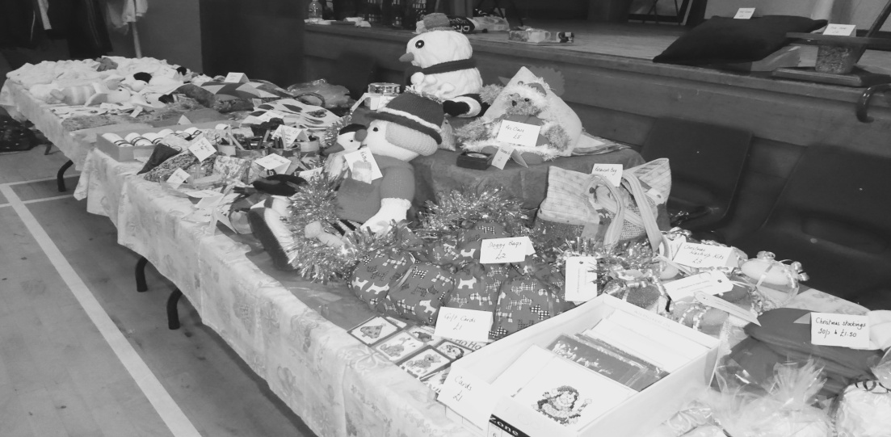

CAN YOU HELP WITH SUNDAY MORNING TEAS?

Thank you to those people who provided the teas following the service during March, April, May and June. Volunteers are required for the coming months. If you can manage to help with the teas please speak to Sheena Anderson.

PROPOSED BOYS BRIGADE
IN THE HUB, RAVENSCROFT STREET

A parent information night will be held in the Hub, 6 Ravenscroft Street on Friday 6th September 2019 at 6.30pm until 7.30pm which will be the place and time for Boys Brigade.

Anchors aged 5-8 programme activities include games, craft, stories, based on 5 areas - body, mind, spirit, community and creativity the emphasis being on fun.
Uniform for anchors is a blue polo shirt and read sweatshirt.

Juniors aged 8-11, same 5 areas as anchors, children encouraged to work more as a team and to have some responsibility, badge work encouraged.
Uniform blue polo shirt and royal blue sweatshirt.

Company Section aged 11-15. Discover programme based on 3 areas - Community, recreation and skills.
Uniform blue shirt and tie or blue polo shirt and blue sweatshirt.

Cost £2.00 per week to cover snack, crafts etc.

All sections are open to girls as well as boys.

******************************

FUNERALS

Bill Rendall, Craigour Avenue, Edinburgh

Our thoughts and prayers are with Moira and the family at this sad time.

IN TIMES LIKE THESE

We read the headlines daily and listen to the news,
We shake our heads despairingly and glumly sing the blues,
We are restless and dissatisfied and we do not feel secure,
We are vaguely discontented with things we must endure….
This violent age we live in is filled with nameless fear
As we listen to the newscasts that come daily to our ears
And we view the threatening future with sad sobriety
As we’re surrounded daily by increased anxiety….
How can we find security or stand on solid ground,
When there’s violence and dissension and confusion all around
Where can we go for refuge from the rising tides of hate,
Where can we find a haven to escape this shameful fate…
Instead of reading headlines that disturb the heart and mind.
Let us open up the Bible and I doing so we’ll find
That this age is no different from the millions gone before,
But in every hour of crisis God has opened up a door
For all who seek His guidance and trust His all-wise plan,
For God provides protection beyond that devised by man….
And we learn that each tomorrow is not ours to understand
But lies safely in the keeping of the great Creator’s hand,
And to have the steadfast knowledge that we ever walk alone,
And to rest in the assurance that our every need is known
Will help disperse our worries, our anxieties and cares
For doubt and fear are vanquished in the peacefulness of prayer.

******************************

Happy birthday to Dilma Mackenzie who celebrated her 50th birthday in June

RECIPE CORNER

At last we have received our first recipe and it is as follows:-

BETTY’S TRAY BAKE

400 gms Condensed Milk
200 gms Butter
200gms Good chocolate
400gms Digestive biscuits crushed

METHOD
- Melt chocolate and butter, add condensed milk and mix well.
- Add the biscuit and mix well.
- Spread into a 12 x 9 baking tray.
- If desired use more chocolate melted to cover the top.
- Cut into squares when cool and enjoy.

Keep the recipes coming folks so that we can keep the recipe corner going.

********************

BADMINTON CLUB

If you would like a little exercise you can come along and join us on a Thursday night from 8 – 10pm. This is for anyone 18 years old and over. Come and have some fun. Contact Janice on 664 8773 for any further information.

REV. RONALD MAXTON
MINISTER OF TRON KIRK 1968 - 1989

Ron Maxton, who died on the 7th June this year, was minister of the Tron Kirk, Moredun from 1968 to 1989. He served during a time when there were many young families in Moredun and he played a significant role in establishing strong bonds with the two primary schools which existed at that time. He regularly found himself with several baptisms at a time but they were always very personal, meaningful and sensitive services.
His great love of music and his own skills as a musician influenced many of our morning services and some may remember the words of the hymn he wrote to be sung to the tune ‘Moredun’ which is included in the church hymnary. Another of his great interests was history and he enjoyed researching our links with the old Tron Kirk in the High Street.

Ron’s orange VW beetle was a common sight in the area as he was a regular visitor to the elderly, the housebound and those in need in the congregation. His driving speed would have suited our local council’s current push to reduce the speed limit to 20mph as he was known for moving slowly but he always got there on time.

Ron Maxton enjoyed food and was a good cook. Many of the office bearers and members had opportunities to enjoy the hospitality of the Manse and sample Ron’s homemade soups and pasta dishes.

He was a quiet, sincere and gentle man with a wry sense of humour, easily identified as he always wore a muffler (woollen scarf) even on an exchange visit to Texas in mid summer!

Ron was held in high regard by the congregation he served in the Tron and that was confirmed by the number who joined his many friends at the Thanksgiving service to celebrate his life, work and Christian witness held in Dunipace Parish Church on Wednesday 19th June.

BASICS BANK UPDATE

It has now been over 2 years since the basics bank opened its doors. Can you believe it? We have given out over 15,000kg of food. We have helped single people, couples and families, giving out food and other basics like toilet paper, shower gel and toothpaste.

The most popular items we give out are sugar, jam, custard and coffee and only one client has said no to biscuits so far! We have helped people who are diabetic, who have food intolerance and who have religious or cultural food needs. And of course we prepare and serve a two course meal every Friday, which is greatly appreciated by clients and volunteers alike.

We have helped people who are just going through a tough patch, people whose benefits have been sanctioned or withdrawn, people who are
struggling through the benefit appeal process, people who have lost their jobs, who are just getting back to work and people whose family circumstances have just taken the rug from under them. A special mention is due to our friends from YPeople, who ably give advice to people perplexed and struggling with the benefits system and help them see the way through the maze.

To be able to do that, there are a lot of people I would like o hank. We are grateful to the Cyrenians FoodShare initiative, who provide us with food each week and especially to Cammy who goes to collect the food and, somehow or another, gets more than we expect on a regular basis.

Thank you to all the volunteers who turn up faithfully every Friday to mark tins, make people welcome, drink tea and coffee, fill bags, clean tables, make food and do the dishes. Without them, we couldn’t run the Basics Bank. We are always on the lookout for willing volunteers, so don’t be shy. You are guaranteed a warm welcome and a great laugh.

I have been blessed and challenged by the Basics Bank, but I never fail to be amazed at how generous, patient, kind and accommodating people are and how wonderful God is to bless us in our service to the community.

So pray for the Basics Bank – pray that one day it will not be needed, but thank God that while it is needed, there ae still people willing to give their time, willing to donate food and basics, willing to lift us up to God in prayer.

Blessings, Janet

HEALING BIBLE STUDY

Healing Bible Study is held in the Tron church on a Monday. Anyone is welcome to join this.

******************************

TRON KIRK COMMUNITY CHOIR

DO YOU LIKE TO SING: If so then come along and join the Tron Kirk Community Choir which meets on Mondays in the Tron Kirk

******************************

DROP IN CAFE AT GOODTREES CENTRE

The Tron Church has a weekly drop in café in Goodtrees Neighbourhood Centre on a Tuesday from 2.00-4.00pm. Tea and biscuits are supplied. All welcome for a cup of tea, a chat and friendship.

******************************

PRAYER GROUP

Every Wednesday in The Tron, 11.15am until 12.15pm.

******************************

COMMUNITY LUNCH

Every Wednesday in the upper hall of Tron Church at 12.30pm. Anyone is welcome to come to this so please come along and join us for a nice lunch.

